BREW MAKES FIRST DONATION TO WASRAG AS START OF COLLABORATION
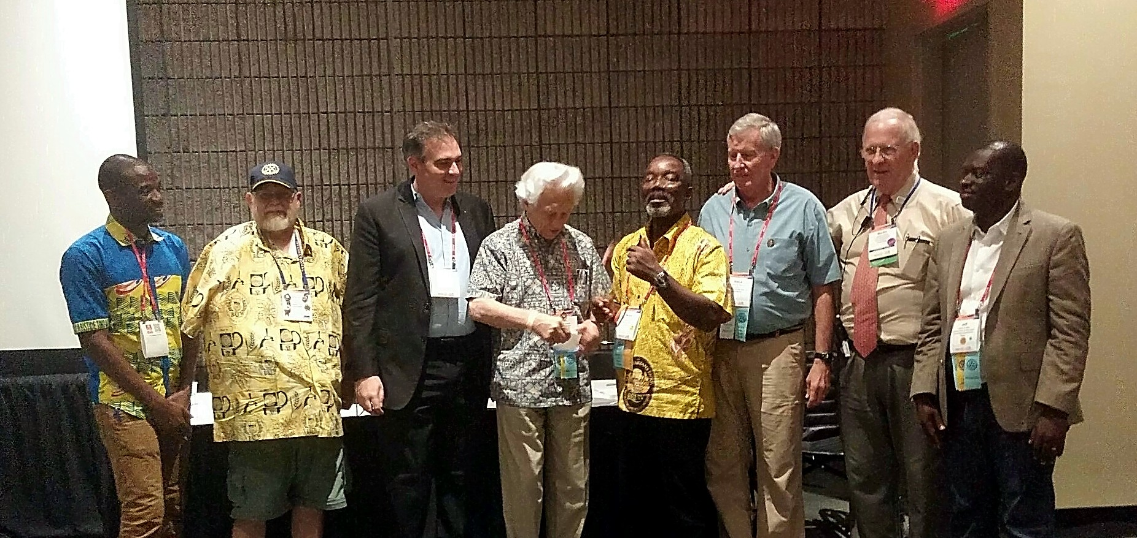Since water is the main ingredient in beer, we have an intense desire to bring clean water to the world.

This is also one of the main goals of Rotary international. We believe the most effective way to accomplish our goal is to partner and collaborate with the Rotary Water and Sanitation Action Group (WASRAG). They work to implement Rotary water service projects around the world.

WASRAG's Board has voted to approve e our partnership and support BREW's clean water efforts
The collaboration between BREW and WASRAG (Water and Sanitation Rotary Action Group) moved forward with a $2500 donation from BREW to WASRAG at our Annual General meeting at the RI Convention in Atlanta.
This donation is the first of future donations that implements our decision to donate 25% of our annual membership revenue to WASRAG every year at the RI Convention.

BREW is beginning work to create a campaign to solicit donations from breweries large and small around the world to replicate the commendable efforts of Stella Artois in supporting clean water projects.

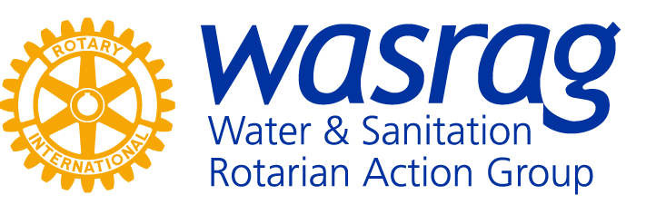
WASRAG has agreed to create specific geographic accounts in their WASRAG Foundation so that donors can specify which areas of the world they would like to donate to for clean water projects.
For example, donors can specify that their donations go to projects in South America, India, Africa, or the Philippines, etc. Then WASRAG would designate projects in those specific geographic areas to receive the donated funds and notify BREW of the projects. Stay tuned for progress reports.

